UK Gender Pay Report 2025

Contents
2025 Gender Pay Report 1
Definitions in respect of gender pay and bonus gaps 2
Differences in gender pay between men and women in 2025 2
Gender profile 2
Gender Pay Gap – Hourly Pay as at 5 April 2025 3
Table 2: Overall mean and median gender pay gap as at April 2025 3
Table 3: Median and average pay gap by quartile as at April 2025 3
Gender Pay gap – bonus payments in the 12 months to 5 April 2025 4
Table 4: The data for bonus payments: Bonus gender pay gap (average and median) 4
How are we addressing the gap? 4
Summary 5

2025 Gender Pay Report

Murgitroyd is a full-service intellectual property firm with a commanding presence across Europe, the Americas and Asia. This report focuses on our UK business only. In this reporting period we had 285 UK employees: 186 females and 99 males. The report excludes colleagues on long-term sick leave and parental leave.

Gender pay shows the aggregated difference in average hourly earnings between men and women, regardless of seniority, experience and other differences in role, at a specific date i.e. 5th April 2025. In this way, it differs from equal pay which looks at differences based on gender within equal, or like-for-like roles.

Different jobs attract different levels of remuneration and similar to other companies in professional services, our gender pay gap is largely due to the type of job roles undertaken by both women and men. This is outlined in more detail later in the report.

In relation to the gender profile across STEM (Science, Technology, Engineering and Mathematics) based disciplines (which feed our Patent Attorney group), it is reported that the STEM graduate ratio is at an all-time high, up 38% since 2020 with Core-STEM degrees accounting for 1 in 5 (18%) of all degrees, highlighting the growing popularity and career opportunities available within the STEM sector. That said, there remains a significant gender gap. Of the 191,000 achieved in 2023/24 only 58,755 of core-STEM qualifications were achieved by women in 2024, less than a third to the total number of qualifications. (https://www.wisecampaign.org.uk/2023-2024-core-stem-subjects-higher-education-statistics/).

UK Government Policy:
In February 2025, the government set out its stance on encouraging more girls to study STEM subjects in a written question response. Baroness Smith of Malvern, the minister for skills and the government spokesperson for equalities, said that the government continued to support the take up of STEM subjects by girls and women in HE. She argued that such skills are crucial for the delivery of the government’s missions and said it was building a “coherent, flexible, high-quality skills system to break down barriers to opportunity and drive economic growth”. She explained this would be underpinned by a new post-16 education and skills strategy.

Set against this backdrop, we acknowledge the need for all participants in the IP sector to support the advancement of women within the sector. As such we remain actively engaged with IP Inclusive, participate in industry groups and various panels focused on enhancing the role of women in IP including their representation, advancement and impact across the whole sector.

Definitions in respect of gender pay and bonus gaps
Hourly Pay:
The rate of pay individuals received for one hour, on the snapshot date of 5th April 2025, regardless of their role.

Mean, or Average, Pay Gap:
The difference between the average hourly rates of pay for female vs. male employees as at 5 April 2025. The mean is calculated by adding all the individual hourly pay rates and dividing by the number of individual hourly pay rates.

Median Pay Gap:
The difference between the median hourly rates of pay for female vs. male employees as at 5 April 2025. The median is calculated by ranking all the individual hourly pay rates in numerical order (low to high), then finding the number that’s in the middle. That number is the median.

Pay Quartiles:
These are calculated by ranking employees’ hourly pay in numerical order, (low to high), then dividing these into four equal quarters. In the tables and charts that follow below each quartile is reported as:
- Quartile 1: Lower, i.e. those earning in the lowest 25% of the population
- Quartile 2: Lower Middle, i.e. those earning above 25% and up to 50% of the population
- Quartile 3: Upper Middle, i.e. those earning above 50% and up to 75% of the population
- Quartile 4: Upper, i.e. those earning above 75% of the population

Differences in gender pay between men and women in 2025

Gender profile
Murgitroyd’s gender profile remains one-third male and two-thirds female. In some roles within Murgitroyd, such as Paralegal Support and Paralegals, women make up a significant proportion of the population. This is reflected in the Lower and Lower Middle quartile data. The Attorney group, including director-level roles, is 35% Male and 65% female. They are reflected in the upper middle and upper quartiles. Chart 1 below shows the percentage of Male and Female within each of the four quartiles.
Chart 1.
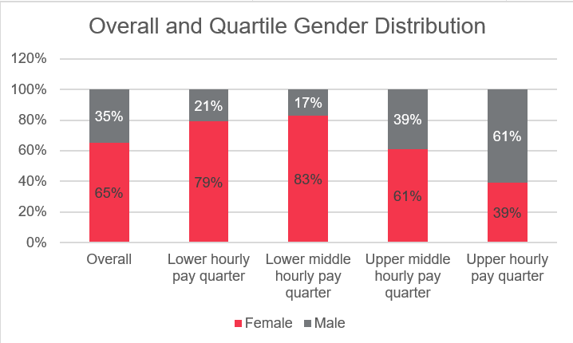

The gender profile by roles has a significant impact on the overall gender pay gap reported in Tables 2 and 3 that follow.

Gender Pay Gap – Hourly Pay as at 5 April 2025

In Table 2 below, the reported average (Mean) gender pay gap is 42.2%. The major cause of this difference is the gender profile of roles, with the significant proportion of female colleagues in the Lower and Lower Middle quartiles as outlined in Chart 1.

Table 2: Overall mean and median gender pay gap as at April 2025
Pay | Mean | Median
Hourly Pay | 42.2% | 51.8%

For greater context, Table 3 shows the gender pay gap overall and for each quartile.

Table 3: Median and average pay gap by quartile as at April 2025
Gender | All | Lower | Lower Middle | Upper Middle | Upper
Median GPG by Quartile | 51.8% | -2.6% | -4.6% | 10.7% | 13.43%
Average GPG by Quartile | 42.2% | -0.2% | -2.5% | 9.1% | 8.2%

This data highlights the gender pay gap in the Upper Middle and Upper quartiles and also reflects the impact of the gender profile in the Lower and Lower Middle ranges (both at 80%+ Female).

Negative percentages reflect where female colleagues are paid more than male colleagues within those quartiles (e.g. Lower Quartile and Lower Middle Quartile), based on the average and median data captured.

Gender Pay gap – bonus payments in the 12 months to 5 April 2025

Table 4 shows the average and median bonus pay gap for the 12-month period to April 2025. Some of the bonus payments included in the data set were paid to staff acquired following business acquisitions and are payable under contractual arrangements within this period.

Table 4: The data for bonus payments: Bonus gender pay gap (average and median)
Pay | Mean | Median
Bonus | 48% | 21%

62% of females and 67% of males received a bonus payment in the 12-month period up to April 2025.

How are we addressing the gap?

Murgitroyd is committed to creating and maintaining a truly equal, diverse and inclusive work environment, where everyone has an opportunity to achieve success and realise their potential. We continue to address a range of activities across the organisation, involving recruitment, development and daily leadership actions.

The business continues to evolve in line with changing client demand and the influence and advancement of new technologies. That said, we remain focused on our ESG strategies including the development and advancement of a diverse range of talent through the organisation. Against this backdrop we continue to review and develop our reward strategy and do so with an eye to equality and diversity. Our performance and career development framework (myFocus) has been fully rolled out and supports performance reviews, career development and personal development conversations at all levels and across all disciplines.

A number of improvements across a range of organisational development practices have also been implemented including the development of the Attorney Career Progression Framework, the implementation of a Management Essentials programme for all line managers and a dedicated training manual for Patent Scientists) with much of the implementation of this work informed by consultation with colleagues across the company.

We also recognise that improved policies, as well as practices, are crucial to removing barriers in the workplace, particularly for women. We are strongly supportive of hybrid and flexible working and are committed to optimising new ways of working that advance equality, diversity and inclusion. Our Values and Behaviours Framework reinforce the values and behaviours that make Murgitroyd a more equal, diverse and inclusive organisation.

As we move forward, we must ensure that opportunities for progression are equitable and that all avenues are explored to encourage and support female colleagues to come into the business and progress through into more senior roles across Murgitroyd.

As an example for the last two years, we have led an initiative to facilitate a pathway into the profession for graduates across a more diverse socio-economic spectrum. Our European Patent Pipeline Programme (EPPP) has provided talented graduates with internship opportunities, with several progressing into Patent Traineeships within the business. Notably, all participants to date have been female, supporting our commitment to increasing the representation of women in STEM and within the IP profession.

Our work to date is reflected in the Gender Pay Gap Report, which shows an overall reduction of 1.7% from the prior reporting period. The latest report also illustrates a 2.8% reduction in the average gap within the upper middle quartile (11.9% reduced to 9.1%) and a reduction of 5.8% in the median pay gap within the upper middle quartile (16.5 to 10.7%). This is significant as this is the level at which we would expect to see our attorney talent come through the organisation into post qualified attorney roles. This being a key future talent pipeline. All that said, we recognise that there is work to be done and so will continue to focus on reducing the overall gap further in future reporting periods.

Summary

We are committed to creating and maintaining a truly diverse and inclusive work environment and a business where everyone can realise their potential and achieve success. Our approach to equality, diversity and inclusion will continue to inform our business strategy and organisational development activities including recruitment, career progression, development, reward and wellbeing.
As in prior reports, while the data and analysis that inform this report are UK specific and are formatted to meet UK regulatory requirements, we are committed to pursuing strategies and actions designed to deliver an improved gender pay balance in all roles and at all levels of the company across our global network.

John Gillies
Chief People Officer
February 2026

